How to install the Roaming Client

Open web browser and go to: <https://www.dnsfilter.com>

See **Mike's Passwords.docx** under the Richard leaving folder on the O drive for the username and password.

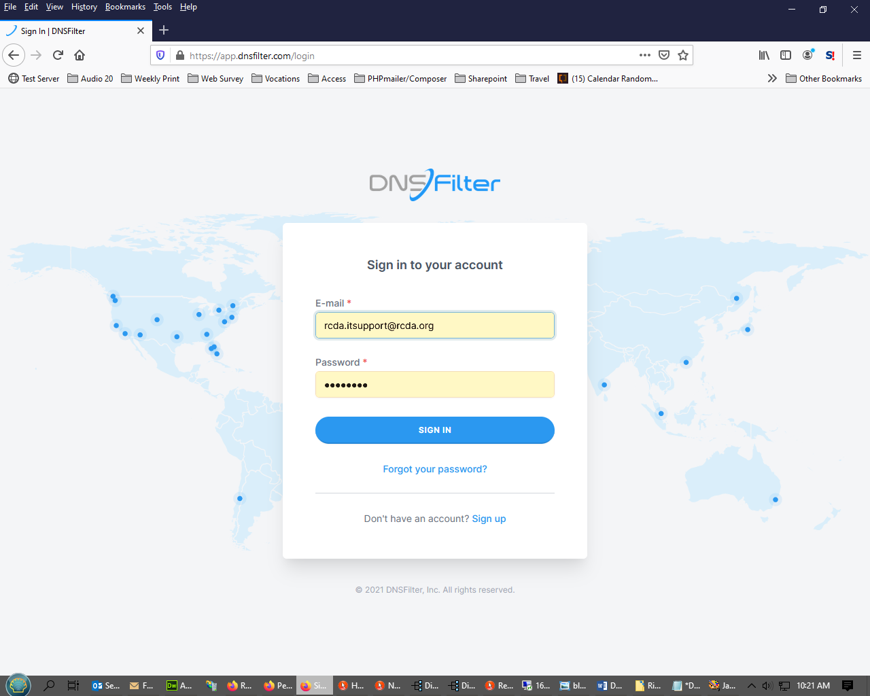

Under **Deployment**, select **Roaming clients.**

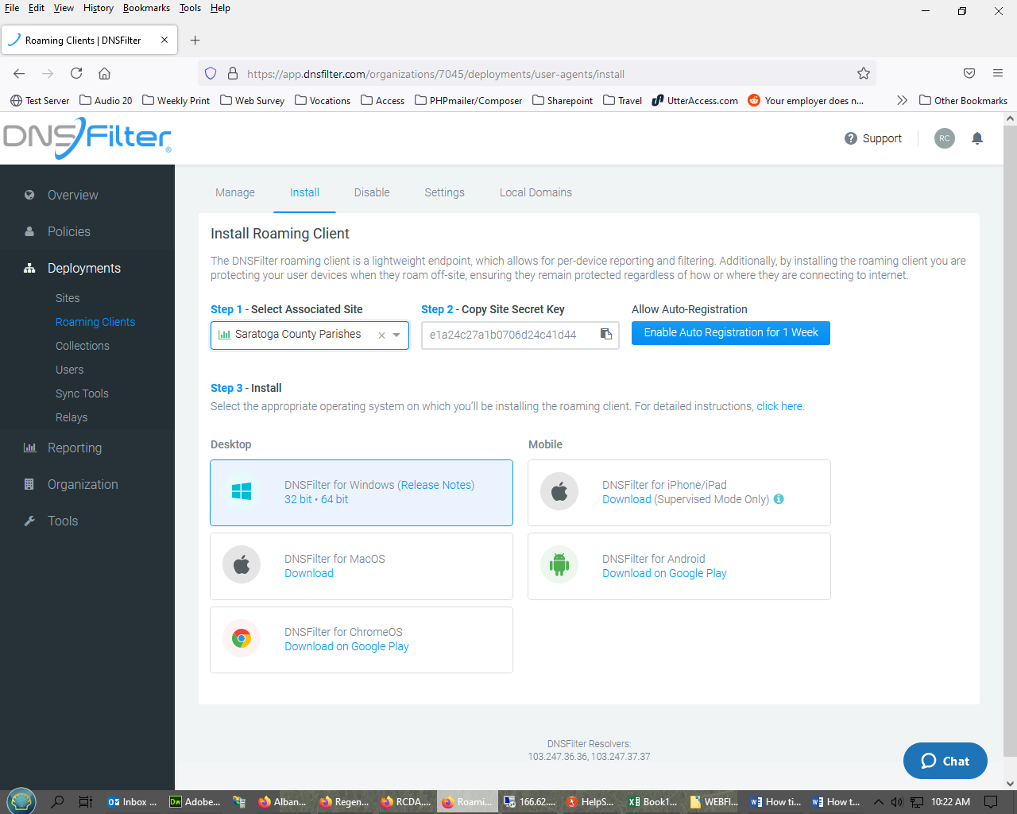

**Step 1:** Open notepad and enter the following code:

msiexec /qn /i "C:\DNSFilter_Agent_Setup.msi" NKEY="e1a24c27a1b0706d24c41d44" HOSTNAME="Saratoga-St Mary's Ballston Spa - Fr. Vivacqua desktop" ARPSYSTEMCOMPONENT=1 TRAYICON="disabled"

**Step 2:** Select **Associated Site**: St. Mary’s, Ballston Spa is in Saratoga County Parishes.

**Step 3:** Copy the **Site Secret Key**.

**Step 4:** replace the **NKEY** with the code you copied in step 3.

**Step 5:** replace the **HOSTNAME** with a name for the PC/Laptop

**Step 6:** Download the DNS filter installation media and save it to the root of the C drive

**Step 7:** Open a command prompt and run the modified code you created in Notepad

**Step 8:** You will not see the installation program on the screen as this is a silent installation. It will take a moment to install.

**Step 9:** You can verify that the program is installed by running the installation media via command prompt. To not run a silent installation, remove **/qn** from the command line code you created in Notepad. If the program offers you an option to uninstall, then the program has been installed.

**Step 10:** Delete the installation media from the root of the C drive

Complete. The DNS Filter has been installed. It will not appear as a trey icon or in the list of installed programs.